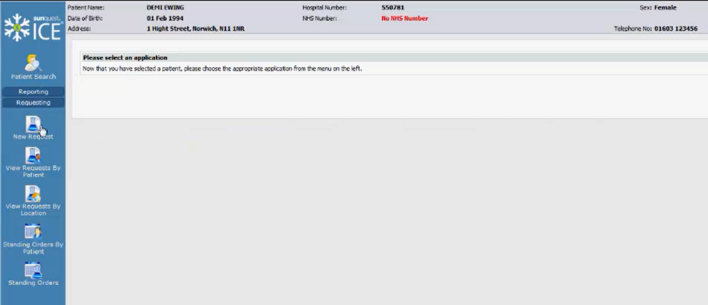

iRefer (CDS) is a Clinical Decision Support tool integrated into Clinisys ICE. Place an imaging request as you do today. For qualified requests, iRefer CDS will automatically launch to recommend clinically appropriate requests(s) based on selected indications for the study.

## Order Entry in Clinisys ICE:

1. Open a patient chart in Clinisys ICE.
2. Select **New Request** from the left-hand menu to request imaging.
3. Select the desired modality tab, e.g. **CT, MRI & US**.
4. Select the desired procedure.

**iRefer CDS starts automatically in an embedded window.**

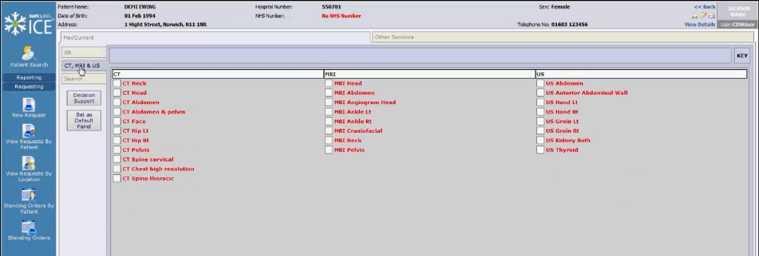

## iRefer CDS:

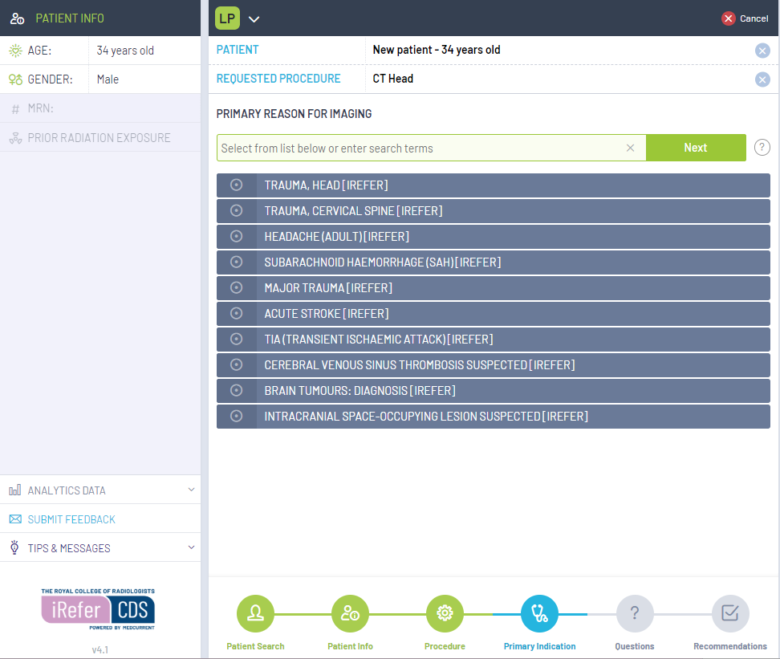iRefer CDS starts automatically in a separate window.

**To re-size the window:**

- Manually select a corner and drag

**To change the magnification:**

- Ctrl + to increase

- Ctrl - to decrease

These settings will be remembered between sessions.

**Step 1: Select Indication** from the list of common indications.

**Note**: If the desired indication is not listed, search by keywords, synonyms, or acronyms. Selecting the will provide tips on optimizing your search.

**Step 2: Answer Questions** (if required)

Questions *may* be presented based on the clinical indication. Answers to these questions allow iRefer CDS to refine the clinical situation and generate the most appropriate recommendations.

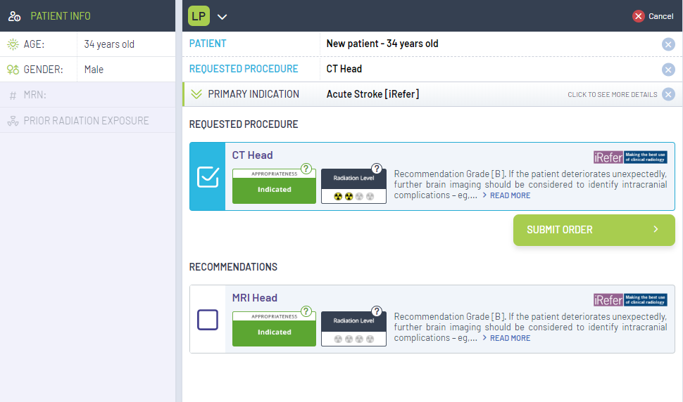**Step 3: Review Recommendations**

Each recommendation has:

* Color coded Appropriateness Score
* Radiation Level
* Advice text clarifying the score assigned

The requested procedure is listed first, with recommendations listed below. You can either continue with your original selected procedure, or select a new procedure based on the recommendations provided. Check the desired procedure and select SUBMIT to return to ICE to complete/sign the request.

1. Selectto return to a previous step in the workflow
2. Selectto view info on Score or Radiation Level rating scales
3. Select the Source logo to view the full evidence supporting the recommendations

**Special Case – Free Text Indication**

If you are unable to find the desired indication, you can create a free text indication by entering the indication and selecting **Submit Free Text**. No recommendations will be provided; however, you may proceed with requesting the requested procedure.

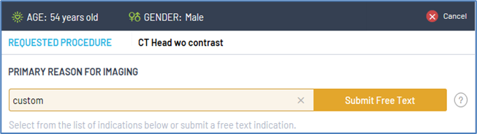

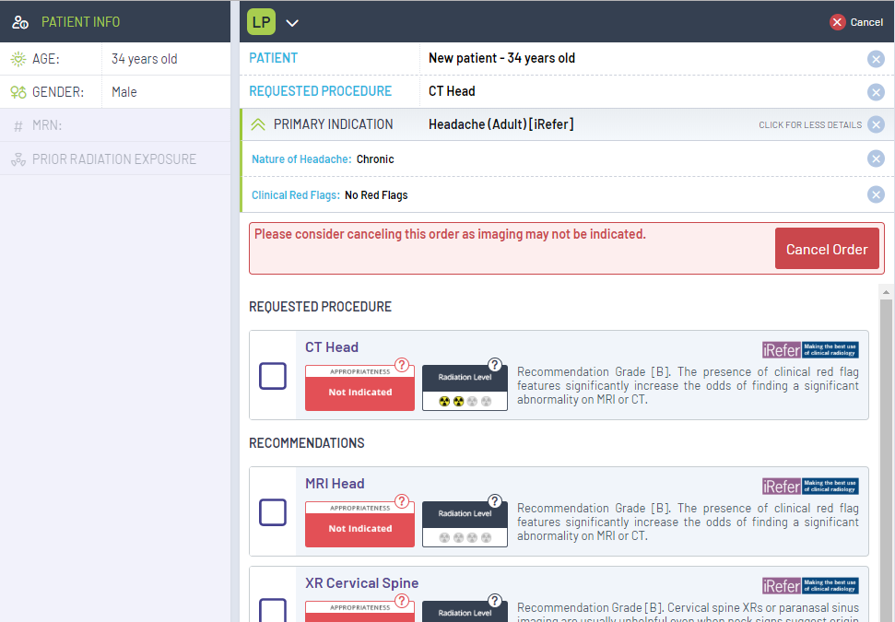**Special Case - Imaging Not Recommended**

In scenarios where no imaging is recommended and all procedures have a red-coded score, a Cancel request button will display. Review the advice text for the clinical reason for this scoring and proceed with cancelling the request if appropriate.

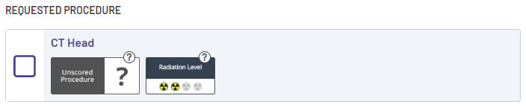

**Special Case - No Recommendations Available**

A grey **Unscored Procedure** icon on the recommendations panel occurs when the answers provided to the preceding questions have resulted in a scenario where there are no recommendations per the guideline.