Referral proforma for Semen Analysis

Cambridge IVF • Kefford House • Maris Lane • Trumpington • CB2 9LG 01223 349017

Patient's details: (please print or apply patient ID sticker)

Surname: NHS No:
Forename: Hosp No:
Address: Date of birth:
Contact Tel:
Postcode:
Partner’s details (if applicable):

Surname: DOB:
Forename:

Referring GP's details: (please print or apply GP stamp ensuring name and address are clear)

Name:
Surgery address:
Surgery Tel: Surgery Fax:
GP Signature: Referral Date:

Clinical details: (please tick relevant boxes below; if no boxes are ticked the sample cannot be processed)

Previous analysis at: Cambridge IVF Other (Please state) ……….. ………. ….. None

Type of analysis required: Diagnostic Semen Analysis Post Vasectomy Semen Analysis

Other special or specific tests required: (please state)

Relevant condition / medication: (please state)

Please complete this section after you have produced your sample:

Sample produced on: dd / mm / yyyy Time of sample: hh : mm

Number of days since ejaculation: Did any of your sample miss the pot? Yes No

To enable us to provide you with the best possible service please note the following important information:
- Samples produced at home must be delivered within 60 minutes
- Abstain from sex or masturbation for 2–5 days prior to your visit
- If you arrive late or without an appointment or do not bring your referral form we will not be able to see you
- Test results will be sent to your doctor within 72 working hours

- To book your appointment please call 01223 349017
- Please arrive on time for your appointment
- Cambridge IVF is NOT Addenbrooke’s Hospital
- Parking is free, please use yellow parking bays only
- Bring this form with you to your appointment
Finding Cambridge IVF

Please note that Cambridge IVF is not located on the main Addenbrooke’s Hospital Campus.
We are very easy to access by car, public transport and bicycle. When approaching the centre along Trumpington Road, look out for Bidwells Estate Agent (next to the Shell garage) on the corner of Maris Lane. Kefford House is immediately behind this complex of buildings and shares a parking lot with them.

Getting here by car
The centre is just off Trumpington Road, easily accessible from the M11 and A11 if coming from outside Cambridge. There is plenty of free parking at the centre indicated by yellow parking bays marked with a ‘K’. It is important that you use these parking spaces and not the others which are allocated to other buildings. You can also park at the Trumpington Park and Ride and take a bus. There is a stop close to the centre on Trumpington Road (see below).

Cycling to Cambridge IVF
There is ample covered cycle racking provided directly outside of Cambridge IVF for those wishing to cycle.

Public transport – Getting to Cambridge IVF by bus or train
The Trumpington Park and Ride service (Stage Coach route number 88) stops at Anstey Way, on the corner of Maris Lane going towards Cambridge. You can get the same bus from Downing Street in Cambridge city centre. Note: Do not get the guided bus service from the Park and Ride to Addenbrooke's hospital. This does not pass Cambridge IVF.

The Stagecoach ‘Citi 7’ bus runs between Cambridge city centre and Trumpington, stopping at the Anstey Way stop. This service stops at the Cambridge Railway station. There are always taxi’s available at the station as an alternative to the bust service.

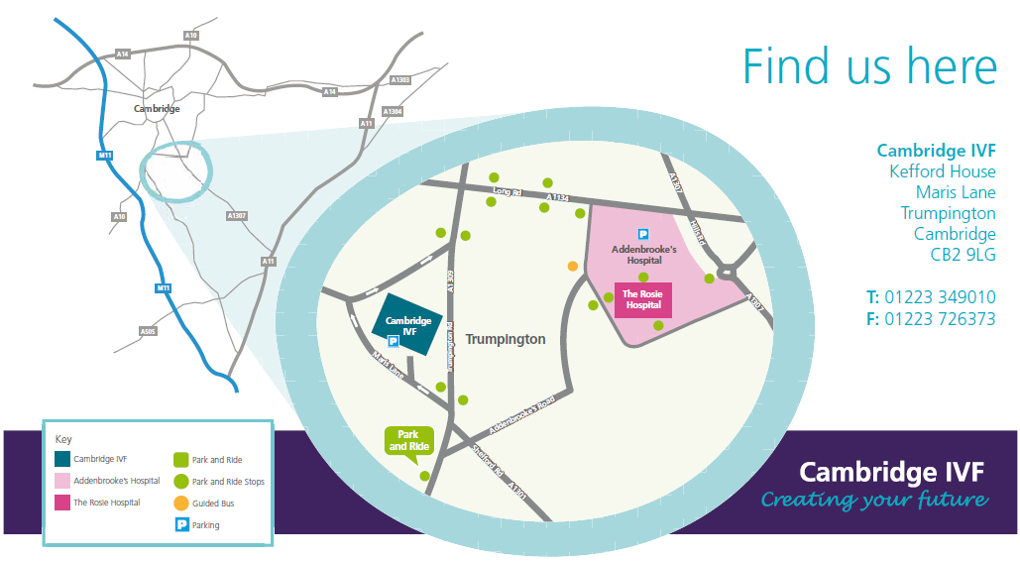

For more information about Cambridge IVF, visit our website at www.cambridgeivf.org.uk

