 
Paediatric Wheeze Discharge Plan >2yrs Old
Patient Name: | Date:
- This is your discharge plan for the next 1 – 2 weeks
Steroid:
- If your child has been prescribed PREDNISOLONE, they should complete a 3 day course & then stop.
- If your child already takes a PREVENTER inhaler (Steroid/Brown inhaler), restart this the day after completion of the prednisolone.
Inhaler Technique:
- Are you confident with the technique of using the inhaler and spacer?
- If you are in any doubt please ask for a demonstration
Follow up:
- Please make appointment for your child to see GP 48 hours after discharge for a review.
- If your child takes MONTELUKAST then this should continue throughout the wheezy episode
- If your child is over 5 years old, you should know how to test their PEAK FLOW. We can show you how to do this before you go. Peak Flow can be helpful when assessing when your child is becoming unwell. If you don’t have a PEAK FLOW METER, get one from your Practice Nurse or GP

Reducing Plan for Salbutamol (BLUE) inhaler
ALWAYS GIVE INHALERS VIA THE SPACER
Day | No of puffs of Salbutamol | Frequency
1 | 10 | Every 4 hours
2 | 6 | Every 6 hours
3 | 4 | Every 8 hours
4 | 2 | Every 12 hours
Day 5 onwards | Use inhalers as and when required

If your child becomes wheezy again:
What to look out for: | What to do:
Green Zone: All Clear!  - No Symptoms  - Able to do everyday activities and sleep without symptoms  (PEAK FLOW BETWEEN 80-100% OF NORMAL)* | Continue any regular medications (eg steroid inhaler)  Salbutamol 2 puffs if mild wheezy episode or before exercise if necessary
Yellow Zone: Beware!  - Night-time cough  - Cough and wheeze on exercise  - If they have a cold  - Sudden chest tightness, wheeze or shortness of breath  - Using stomach muscles to breathe more than normal  (PEAK FLOW BETWEEN 50-80% OF NORMAL)* | Continue any regular medications (eg steroid inhaler)  Salbutamol 2-4 puffs 3-4 hourly via spacer  If not settling in 24 hours contact GP/Practice Nurse.  If getting worse try: Salbutamol 6-10 puffs 4 hourly  Arrange to see GP/Practice Nurse that day.  Move to RED zone immediately IF:  - You don’t feel better in 20 minutes  - OR Improvement lasts less than 4 hours  - OR The problem continues for >24 hours
Red Zone: Emergency!  - Coughing,wheezing & very short of breath  - Drawing in around the ribs  - If their lips or nails are blue, struggling to breathe, too wheezy to talk or walk  (PEAK FLOW LESS THAN 50% OF NORMAL)* | DO NOT DELAY – Attend the Emergency Department  Salbutamol 6-10 puffs every 20-30 minutes via spacer whilst waiting for urgent medical assessment  Call an Ambulance(999) or go to Hospital immediately
*If your child is over 5 years you should check their peak flow
For more information please speak to your GP, Practice Nurse, or visit www.asthma.org.uk
 
Paediatric Wheeze Discharge Plan >2yrs Old

Inhaler Technique using a Spacer

1

2
3
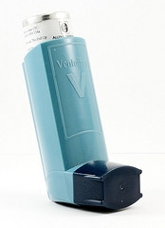
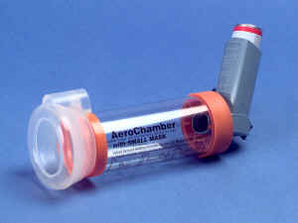
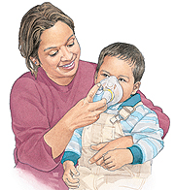
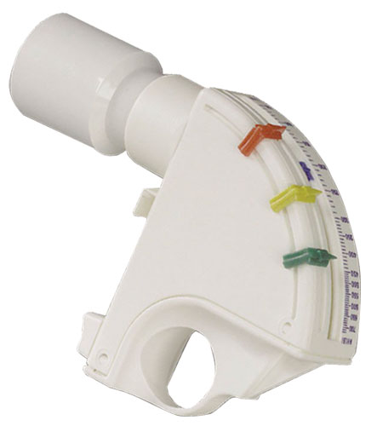
Dustcap
Shake your inhaler and remove dustcap
Attach inhaler to spacer as shown
Place your child in an
up-right and comfortable position. Place the mask securely over their mouth and nose.
Press inhaler once to give one puff and count to ten. Repeat step 1-3 for each puff.

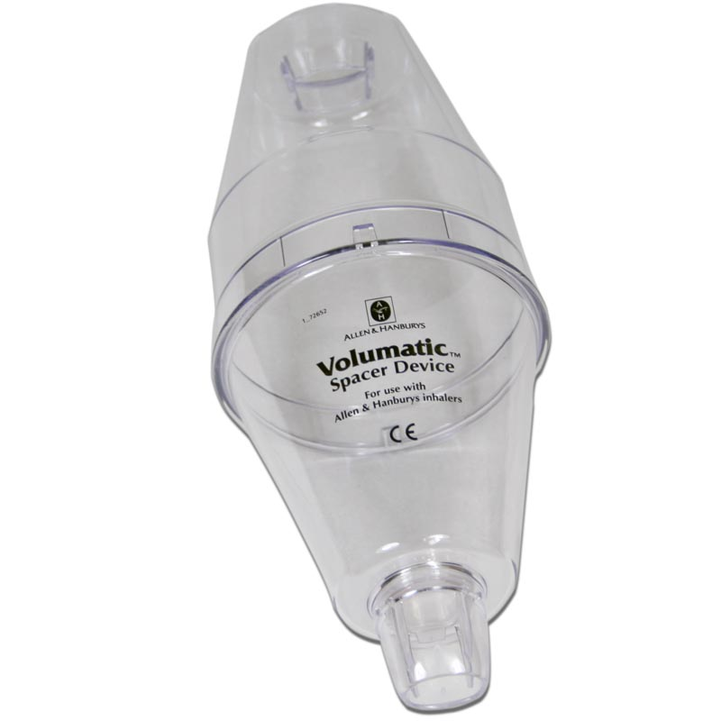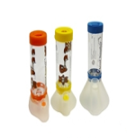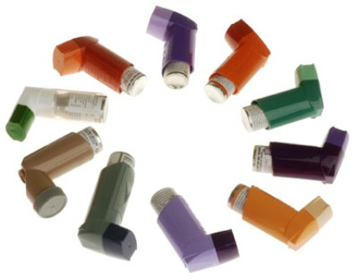

What are the benefits of using a spacer?

- Spacers make the giving of inhalers more effective.
- Many young children are unable to
co-ordinate breathing correctly with administering the inhaler.
- More medication is able to get into your child’s lungs than using the inhaler directly into the mouth.
- Reduces the likelihood of your child’s mouth becoming sore.

Peak Flow Technique for 5 Years and Over
A peak flow is a measurement of how much air you can blow out of your lungs in a set amount of time. Peak flow scores help you to see when your asthma is getting better or worse.
Keeping a peak flow diary is useful because:
- You can tell what is going on in your lungs rather than guessing by how you feel.
- It is a record of how well you have been, which you can also show your doctor or asthma nurse at your asthma review.
- It can help you and your doctor or asthma nurse find out if the asthma medicines you are taking are effective for you.
You get peak flow readings by blowing into a small plastic tube called a peak flow meter. Your readings will vary according to your age, gender, height and how well your asthma is controlled. Ask your doctor or nurse about using one of these and a peak flow diary to help you better control your asthma.



