



Patient information

Preterm Prelabour Rupture of Membranes (PPROM)

Introduction
The purpose of this leaflet is to provide information to women whose waters have broken between 24 and 37 completed weeks of pregnancy. If your waters break before 24 weeks, you should have a discussion with your healthcare professional about your individual circumstances.
We hope this leaflet will help you better understand your health and your options for treatment and care, and how the hospital staff will support you during pregnancy if your waters break early. If you have any questions or concerns, please speak to the midwife or doctor caring for you.

Preterm prelabour rupture of membranes (PPROM)
Your baby is surrounded by amniotic fluid or ‘waters’ contained within a membrane bag (the amniotic sac) inside your uterus. When the waters break, it is also known as rupture of the membranes. Normally your waters break shortly before or during labour.
If your waters break before labour at less than 37 weeks of pregnancy, this is known as preterm prelabour rupture of membranes (PPROM).
This can happen in up to 3 out of every 100 (3%) pregnant women. If this happens, it can sometimes trigger early labour, but not always.
PPROM is associated with 3-4 out of every 10 preterm births. It is diagnosed when pooling of amniotic fluid is seen either on a pad or by internal speculum examination. If you are unsure that your waters have broken and we cannot see any fluid pooling during the speculum examination, we can offer a swab test called the ROM plus test. This is a swab test taken during the speculum examination to check for amniotic fluid. The results take 5-10 minutes.
If your waters have broken, then we would advise that you are admitted to our antenatal ward (Dacre ward) for 48 hours. This is to observe for signs of labour or infection, and to prepare for possible early birth of your baby.

Inpatient management of PPROM
While on Dacre ward, we will carry out the following assessments:
- High vaginal swab (on admission only)
- Observations every four hours (blood pressure, heart rate, temperature, breathing rate)
- Daily monitoring of the baby - If you are over 28 weeks, you will be put on a monitor, called a CTG, to watch the pattern of your baby's heart beat. This is used to confirm your baby’s wellbeing. If you are under 28 weeks, a handheld device called a Doppler will be used instead
- Blood tests
- Oral antibiotics for 10 days to reduce the risk of infection and prolong the pregnancy
- Daily checks by the obstetricians to ensure you receive the right care
- A request for the neonatal doctor to come and discuss care of your baby if labour was to progress

Possible transfer to another hospital
Here at the Lister Hospital, our Level 2 Neonatal Intensive Care Unit (NICU) is best equipped to appropriately care for babies that are born over 27 weeks gestation (or over 28 weeks for twins), and babies who are estimated to weigh over 800g at birth. If your waters break and your baby is below this gestation, or estimated to weigh less than 800g, then we will discuss transferring you to a hospital that has a Level 3 NICU.
A Level 3 NICU is better equipped to provide the best care for your baby if they come before 27 weeks gestation. Ideally, if we do transfer you, this would occur before the birth so that preparations can be made to give your baby the best start. This is known as an in-utero transfer.
If birth occurs before we can safely transfer you, your baby will be stabilised by our neonatal team and then transfer will be arranged once your baby is stable enough to be moved safely.

Giving your premature baby the best start
If it looks like you may be going into labour and that your baby could come early, we may offer you some medications. This is to reduce the risks of complications to your baby and will depend on how many weeks pregnant you are. We may offer:
Steroids – to reduce the risk of breathing difficulties at birth, bleeding in the brain and bowel inflammation. This course of steroids is two doses of an injection into the muscle given over 12-24 hours.
Magnesium sulphate – to reduce the risk of cerebral palsy. This is a drip that is given in two parts. A larger starting dose given by the doctors, followed by an infusion which continues for 24 hours or until your baby is born. If you are to be transferred, the infusion will be stopped for the transfer.
Antibiotics – to reduce the risk of infection as this risk is higher in premature babies. If you are found to be in established labour then we will start antibiotics given through a drip.

Outpatient management of PPROM
After at least 48 hours of inpatient care and monitoring, the doctors will assess to see if it is safe for you to be discharged home. This is usually possible if you have not gone into labour, you and baby are both well, and you show no signs of infection.
It is important for you to know that there is a small risk of sepsis (infection in the blood) linked with PPROM. This is associated with poor outcomes for mums and can possibly impact future pregnancies, which is why we advise you to call Maternity Triage if you have any symptoms such as:
- Raised temperature
- Flu-like symptoms (feeling hot and shivery)
- Vaginal bleeding
- If the leaking fluid becomes greenish or smelly
- Contractions or cramping pain
- Abdominal pain or back pain
- If you are worried that the baby is not moving as normal

On-going monitoring in the Day Assessment Unit (DAU)
Once you are discharged home, we will offer you regular appointments in the Day Assessment Unit (DAU) to monitor you and your baby. This will include:
- Twice weekly checks of your observations (to rule out signs of infection) and to listen to your baby
- Weekly blood tests to check for any signs of infection
- A scan of your baby every two weeks to check they are growing well
- A review with a consultant to plan the rest of your pregnancy care and to plan for the birth of your baby
If you are concerned about yourself or your baby, please do not wait until your appointment in DAU to be checked. Please contact Maternity Triage immediately - Telephone 01438 286168

Timing of birth
If you and your baby are both well with no signs of infection, you may be advised to wait until 37 weeks to give birth. This is because carrying on with the pregnancy reduces the risk to your baby that are related to being born prematurely.
If you are known to carry the Group B Streptococcus (GBS) bacteria, then you may be advised to give birth from 34 weeks because of the risk of GBS infection in your baby. For more information on GBS in pregnancy, please scan this QR code:
Group B Streptococcus (GBS) in pregnancy and newborn babies (RCOG.org.uk)

The consultant obstetrician (and possibly the neonatal doctor) will have a discussion with you about the timing of birth taking into account:
- Your medical history
- The gestation that your waters broke
- If you have GBS infection
- You and your baby’s on-going wellbeing
- Your preference
It is often possible to have a vaginal birth after PPROM but this will depend on when you go into labour, the position your baby is lying in, and your own individual circumstances and choices.

Care in future pregnancies
Having PPROM or giving birth prematurely means that you are at an increased risk of having a preterm birth in any future pregnancies.
You will be advised to be under the care of a specialist team who will discuss with you a plan for your pregnancy depending on your individual situation.

About intimate examinations
The nature of gynaecological and obstetric care means that intimate (or internal) examinations are often necessary.
We understand that for some people, particularly those who may have anxiety or who have experienced trauma, physical abuse or sexual abuse, such examinations can be very difficult.
If you feel uncomfortable, anxious or distressed at any time before, during or after an examination, please let your healthcare professional know.
If you find this difficult to talk about, you may communicate your feelings in writing. Should you wish to do this, please contact the Preterm Birth Team by email on pretermbirth.enh-tr@nhs.net
They aim to respond to emails within 3 working days.

Preterm labour
If you think you are in preterm labour or that your waters have broken, contact the hospital:
- Less than 16 weeks pregnant - Contact the Early Pregnancy Unit (EPU - Woodlands) on 01438 286190 (or attend the Emergency Department if urgent).
- Over 16 weeks - Telephone Maternity Triage on 01438 286168

Useful contact details

East and North Hertfordshire Teaching NHS Trust:
- Website www.enherts-tr.nhs.uk
- Telephone 01438 314333
Early Pregnancy Unit – EPU Woodlands
- 01438 26190
Maternity Triage, Lister Hospital:
- Telephone 01438 286168

Useful websites for more information

NHS website
https://www.nhs.uk/pregnancy/labour-and-birth/signs-of-labour/premature-labour-and-birth/

Tommy’s
https://www.tommys.org/pregnancy-information/premature-birth

RCOG patient information leaflet
https://www.rcog.org.uk/for-the-public/browse-all-patient-informationleaflets/when-your-waters-break-prematurely-patient-informationleaflet/
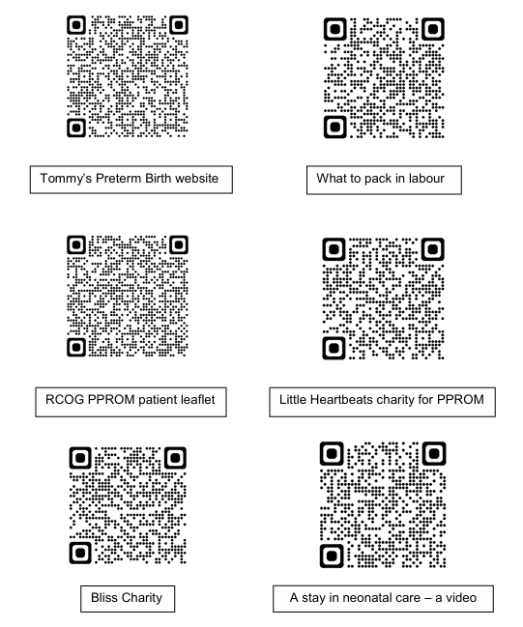

Further reading
There are other maternity information leaflets you may wish to read.
These are available on our East & North Herts NHS Trust website:
www.enherts-tr.nhs.uk/patient-information/

Leaflet information

You can request this information in a different format or another language;
please speak to your doctor or nurse.

Date of publication: August 2023
Version number: 2
Author: D. Thorpe
Reference: Maternity
Review Date: June 2029
© East and North Hertfordshire Teaching NHS Trust
www.enherts-tr.nhs.uk

