



Patient information

Low Molecular Weight Heparin in Pregnancy

The purpose of this leaflet is to provide you with information about Low Molecular Weight Heparin, which may be prescribed during your pregnancy

Introduction
You have been given this leaflet because you have been advised to take low molecular weight heparin (LMWH), a blood-thinning medication, during or after your pregnancy to reduce the risk of a blood clot. This leaflet explains why LMWH is used, how to take it, and important safety information. If you have any questions or concerns, please contact your midwife, obstetrician, or medical team.

What is Low Molecular Weight Heparin?
Low molecular weight heparin (LMWH) is a medication that reduces the blood’s ability to form clots. Some women are prescribed LMWH during pregnancy or after birth because pregnancy increases the risk of blood clots.

What is a Venous Thromboembolism (VTE)?
A venous thromboembolism (VTE) is a blood clot that forms in a vein. Pregnancy increases the risk of VTE.
The most common types are:
- Deep Vein Thrombosis (DVT): a clot in the leg or pelvis (although it can occur in other places)
- Pulmonary Embolism (PE): a clot that travels to the lungs
Rarely, clots can occur in veins in the brain.
Symptoms of a DVT may include:
- Pain in one calf or thigh
- Swelling of one leg or area
- Warmth, redness, or darkened skin
- Swollen veins that are painful or hard
Seek medical advice if you develop symptoms of a DVT.
Symptoms of a PE may include:
- Sudden shortness of breath
- Chest pain or tightness
- Coughing up blood
- Feeling very unwell or collapsing
Seek urgent medical assistance if you experience symptoms of a PE.

Why have I been prescribed LMWH?
You have been prescribed LMWH because your medical team believes you are at increased risk of developing a blood clot, or because you have already had one. LMWH helps reduce this risk.
Your clot risk is assessed at your booking appointment and reviewed throughout pregnancy and after birth. The risk of blood clots is highest in the first few weeks after delivery, so it is important to continue LMWH for as long as your medical team advises.

How to give the injection

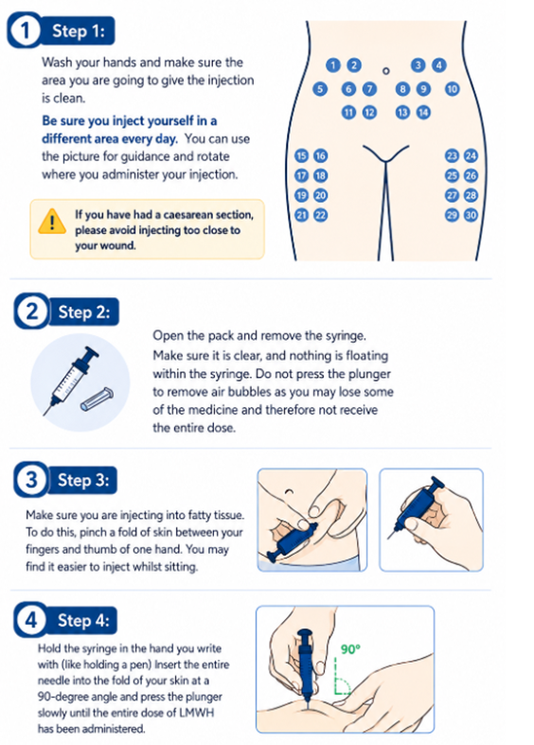

Alternatively this link will take you to a video showing how to give the injection:
https://www.youtube.com/watch?v=39sLVvZHE14

Do not put syringes or sharps bins in household waste. You will need to arrange for your sharps bin to be collected by the local council.

Your LMWH will be prescribed and supplied by your obstetrics team at the hospital – not by your GP.

If you require any advice about injecting your medication, please contact Maternity Triage on the number at the end of this leaflet.

Possible side effects
LMWH can cause bruising or mild swelling at the injection site. Some people develop a skin reaction such as a rash or discolouration. If this happens, contact your midwife or obstetrician for advice. A full list of side effects can be found on the medication leaflet provided with the medication.

Storage
Store syringes in their original packaging, at room temperature, in a dry place. Keep them and the sharps bin out of reach of children.

Before your baby is born
If you think you are in labour or your waters break, do not take further LMWH doses. Contact your maternity unit and tell them when your last dose was taken, as this can affect decisions made surrounding your delivery – including, but not limited to, your ability to have an epidural.
If you are having an induction or planned caesarean section, your maternity team will tell you when to stop LMWH.

Safety of LMWH
LMWH is safe to use during pregnancy and does not cross the placenta to your baby. Small amounts pass into breast milk but are not absorbed by your baby.
Tell your obstetrician about any other medications you are taking, as LMWH can interact with some medicines.

Porcine (pig) content
LMWH is made from pig-derived products. These medicines are widely used because they are effective and well-studied in pregnancy and breastfeeding.
Non-porcine alternatives are limited but may be suitable in some cases. If you do not wish to use porcine-derived medication, speak to your obstetrician or midwife to discuss possible alternatives.

Useful contact details

East and North Hertfordshire Teaching NHS Trust:
- Website www.enherts-tr.nhs.uk
- Telephone 01438 314333
Maternity Triage, Lister Hospital:
- Telephone 01438 286168

Leaflet information

You can request this information in a different format or another language;
please speak to your doctor or nurse.

Date of publication: June 2026
Version number: 1.0
Author: H. Mitchell and E. Fish
© East and North Hertfordshire Teaching NHS Trust
www.enherts-tr.nhs.uk
Reference: Maternity and Pharmacy
Review Date: June 2029

