

Patient information
Neonatal Pulse Oximetry Screening
Information for parents
This leaflet explains our screening program to find babies with serious heart defects that haven’t been seen on a scan before birth. Research has shown that if a baby has a heart defect, then early identification is really important. Often babies who have a problem with their heart may be well soon after birth and then become unwell over the next few days or weeks. If we can find the problem before the baby becomes unwell, we can offer care which can improve the well-being of the baby.
Serious heart conditions in newborn babies are very rare, but by offering every baby the screening test, soon after birth, we can find babies with lower oxygen levels. We can then check these babies very carefully to see if they have a possible heart defect. The screening test is not painful or harmful to your baby and is very quick and easy to do. Your baby will be offered a screening pulse oximetry test, usually within the first 12 hours after birth.

What is a pulse oximetry test and what does it tell us?
A special machine is used that measures the amount of oxygen in your baby’s blood. A small probe is wrapped around your baby’s hand and connected to the machine, which then measures the oxygen levels for one minute by shining a light through the skin. We then move the probe to the foot and repeat the test. The screening takes less than 5 minutes.
Babies with other conditions such as breathing problems, infections and circulation problems often have lower oxygen levels too and the test may also identify these babies. The test is very safe and gives the midwives, nurses and doctors looking after your baby important information about your baby’s oxygen levels.

The test results
We look at the result of the screening test to see if it is positive or negative. A test negative result means that the results are normal. A test positive result means there may be a problem and we will do a further test to check the result. The midwife looking after you will explain the test result and answer any questions you may have. A doctor or specialist nurse will check all babies who do not pass the test to see if further tests or treatments are required. They will explain what is happening with your baby at each step.

My baby has passed the test, what does this mean?
If your baby passes the test this means your baby’s oxygen levels are normal and no further pulse oximetry testing is necessary. Your baby will continue with routine care, including a physical examination. Passing the test does not always mean that there is no problem. A small number of babies (about 1 in every 8000) who pass the test may still have a serious heart problem, so it is important to observe the baby for any changes and complete the routine physical examination.

My baby has not passed the test, what does this mean?
About three in every 100 (3%) babies will not pass the test first time but their oxygen levels will only be slightly low. This might cause some worry for you, but we know that the lungs of some babies adapt to being born at a slower rate than others. This is normal and these babies are healthy. If your baby’s oxygen levels are only slightly reduced in the first test and the baby appears healthy then we will repeat the test a second time 1 to 2 hours later. This is called a re-test.

What happens if my baby is offered a re-test?
9 out of 10 babies will pass the re-test. It is important that the baby’s oxygen levels are normal before going home and so very occasionally this will mean a slight delay in the baby’s discharge (1 to 4 hours), while the re-test is done. Babies who do not pass the re-test (test positive) will be seen by a doctor or specialist nurse used to looking after babies. They will examine your baby and may do other tests to try to find out why the oxygen levels are low, this will include checking for a heart problem

How many babies test positive?
About 3 babies in every 1000 (0.3%) will have very low oxygen levels on the first test which means that they will be seen by a doctor or specialist nurse used to looking after babies straight away. They will examine your baby and may do other tests to try to find out why the levels are so low including checking for a heart problem. About 7 in every 1000 babies tested (0.7%) will test positive either after the first or second test.
What happens if my baby tests positive?
This might cause you to worry but the doctor or specialist nurse will check your baby straight away and explain what is happening. More than half of the babies (six out of every 10 or 60%) who test positive are healthy and they just have slow adaptation to birth. Five out of these six babies will develop normal oxygen levels very quickly and need no investigation or treatment.

What happens next if my baby tests positive?
Five out of every 10 babies who test positive (3.5 out of every 1000 babies tested) will be offered further investigations and almost all will be admitted to the Neonatal Unit (NNU) for further tests to be done. This may make you worried but the doctor or nurse will explain what is happening. Most babies will have blood tests, x-rays and other investigations to try to find out the cause of the low oxygen levels.

Of the babies that go on to be admitted to the neonatal unit (NNU);
- 2 in every 10 will be found to be healthy – these babies will have further tests to confirm this and there could then be a delay in discharge home, but they are usually on the NNU for less than 12 hours.
- 7 in 10 may have a breathing problem or infection and most will have benefitted from the pulse oximetry test as it will have allowed an early diagnosis and treatment of a potentially serious illness.
- 1 in 10 will have a heart problem and for these babies there is significant benefit from the early diagnosis and treatment that can then take place

Summary
In this information leaflet there is a lot of detail to make sure that parents understand the screening, what the test results may show and what care may be offered.

Having a baby with a serious heart defect is rare, but by screening all babies early, maternity and neonatal services have found the outcomes for these rare cases are much improved.
As every baby is an individual the testing positive or negative may mean different things for the baby. All of the professionals working to look after your baby will keep you informed and what the test results mean for your baby so you can understand the pathway of care that may be offered.

We hope you have found the leaflet helpful and please do ask your midwife, nurse or doctor any questions you may have about the screening and the positive benefits of the tests.

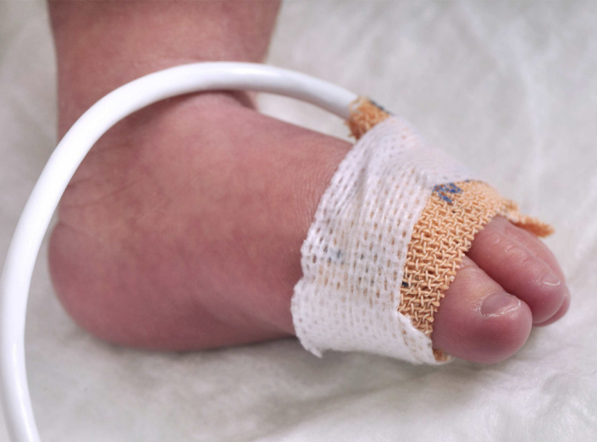

Useful contact details

East and North Hertfordshire Teaching NHS Trust:
- Website www.enherts-tr.nhs.uk
- Telephone 01438 314333

Leaflet information

You can request this information in a different format or another language;
please speak to your doctor or nurse.

Date of publication: XX XXXXX XXXX
Version number: 01
Author: D. Macpherson
Reference: Maternity
Review Date: XXX XXXX

