



Patient information

Choroid Plexus Cyst
The choroid plexuses are structures in the brain that produce the cerebrospinal fluid (fluid which floats around brain and spinal cord). Occasionally fluid becomes trapped and forms pockets in the choroid plexus. These pockets of fluid are called choroid plexus cysts (CPC).

CPCs are identified by ultrasound in approximately 1 - 2% of all pregnancies scanned between 16 and 24 weeks gestation. The cysts may be seen in one or both sides of the brain, and generally have no effect on fetal development.

Causes and risk factors
Choroid plexus cysts are believed to be caused by abnormal folding of the lining of the choroid plexus which traps fluid and debris. A developing baby’s brain may create these cysts as a normal part of development. They are temporary and usually are gone by the 28th week of pregnancy.

In a very small percentage of babies with choroid plexus cysts, there is an associated chromosome disorder called trisomy 18. Babies with trisomy 18 have an extra copy of chromosome 18.

Trisomy 18 (Edward syndrome) is a disorder characterised by severe mental disabilities and multiple abnormalities. Babies with trisomy 18 have choroid plexus cysts about one third of the time. The cause is unknown, though the risk increases with maternal age.

Diagnosis
CPCs are identified on ultrasound at around 18 to 20 weeks gestation. The anomaly scan at this time is directed at detecting fetal abnormalities. A detailed ultrasound, to look for both major and minor findings associated with Trisomy 18, further review may therefore be recommended by the Fetal Medicine Team.

Treatment and prognosis
More than 90% of choroid plexus cysts resolve spontaneously by the 28th week of gestation. Once resolved, the cysts do not recur. The risk of Edward's syndrome seems to be no greater if the cysts are large or small, one-sided or on both, persist later or not.

We understand that this diagnosis may be difficult and we are here to support you. If you have any questions about what we have said, please do not hesitate to contact us by our contact details below

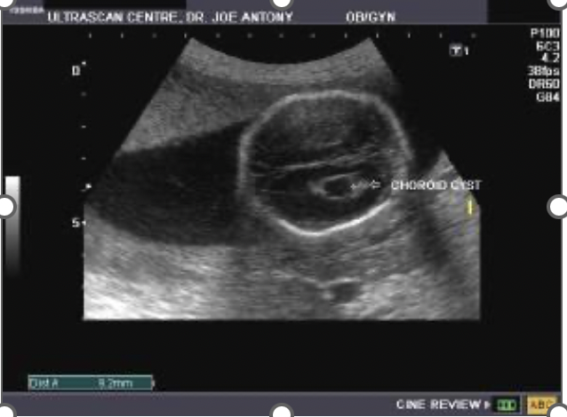

Further information

• ISUOG
International Society of Ultrasound in Obstetrics and Gynaecology (ISUOG)
122 Freston Road, London W10 6TR, UK
Tel: +44 (0) 20 7471 9955
Email: info@isuog.org
https://www.isuog.org/resource/choroid-plexus-cyst----isuog-patient-information-series-pdf.htm

• Edwards Syndrome
https://www.nhs.uk/conditions/edwards-syndrome/

• Choroid Plexus Cyst
http://www.choroidplexuscyst.org/

• NHS Fetal Anomaly Screening Programme
https://www.nhs.uk/pregnancy/your-pregnancy-care/screening-tests/

Useful contact details

East and North Hertfordshire Teaching NHS Trust:
• Website www.enherts-tr.nhs.uk
• Telephone 01438 314333

East and North Hertfordshire Fetal Medicine Service:
Telephone: 07500126406
Email: fetalmedicine.enh-tr@nhs.net

Leaflet information

You can request this information in a different format or another language;
please speak to your doctor or nurse.

Date of publication: XX XXXXX XXXX
Version number: 01
Author: Dr Nehal Shah/ Dr Georgianne Mullings
© East and North Hertfordshire Teaching NHS Trust
www.enherts-tr.nhs.uk
Reference: Maternity/ Fetal Medicine
Review Date: XXX XXXX

