



Patient information

In-utero Transfer

Introduction

The purpose of this leaflet is to provide information to women whose babies may be born before 28 weeks gestation. You may have come to the Maternity Triage with signs of preterm labour, or we are recommending that your baby needs to be born early because we have concerns about you or your baby’s wellbeing. If you have any questions or concerns, please speak to the midwife or doctor caring for you.

In-utero transfer
Here at the Lister Hospital, Level 2 Neonatal Intensive Care Unit (NICU) is best equipped to care for babies born over 27 weeks gestation (or over 28 weeks for twins). If your baby is below this gestation or estimated to weigh less than 800g, we may recommend that you go to a hospital with a Level 3 NICU before your baby is born.
This is known as in-utero transfer. This means transferring the baby while they are still in the uterus. If you give birth in a hospital with a Level 3 NICU, your healthcare team will have immediate access to the right equipment and expertise that your baby needs.
Another reason you may be offered a transfer to another Level 2 or Level 3 NICU is if our Neonatal Unit is closed for any reason. If any of the above apply to you, then we will attempt to find a maternity and neonatal bed for and your baby.
Organising a transfer can take many hours as it involves many telephone calls to other hospitals. In the meantime, we may offer you different medications in an attempt to prolong the pregnancy or to help your baby cope with premature birth if the labour progresses.
A transfer may not be possible if:
- Another hospital doesn’t have enough space to accept the transfer
- You don’t want to go
- There is a risk that you may give birth on the way to the hospital
- • your baby needs to be born as soon as possible
- • you need immediate medical attention, for example, if you have severe pre-eclampsia
- If the labour does progress and your baby is born before the transfer occurs, then our neonatal team will stabilise your baby and, once it is safe for your baby to be transferred, they will arrange the transfer.
- The Neonatal Team are very capable of caring for your baby but in the long term, it will be best for your baby to be transferred to a Level 3 Neonatal Intensive Care Unit once they are stable.

Delaying the birth
We may attempt to delay the birth by giving you some medication if it is safe to do so. This could be oral tablets or through a drip in your veins. The aim of this medication is to help to slow the contractions so that we can safely transfer you to another hospital or to give you other medications that can help your baby cope with premature birth.
It may not always be possible or safe to give you these medications so the doctors will discuss your options with you.

Giving your premature baby the best start
We may offer you some medications to reduce the risks of complications if your baby is born during this time:
Steroids – to reduce the risk of breathing difficulties at birth, bleeding in the brain and bowel inflammation. This course of steroids is two doses of an injection into the muscle given over 12-24 hours.
Magnesium sulphate – to reduce the risk of cerebral palsy. This is a drip that is given in two parts. A larger starting dose given by the doctors, followed by an infusion which continues for 24 hours or until your baby is born. If you are to be transferred, the infusion will be stopped for the transfer.
Antibiotics – to reduce the risk of infection as this risk is higher in premature babies. If you are found to be in established labour then we will start antibiotics given through a drip.

The transfer
You will be transferred in an ambulance and accompanied by a midwife. Unfortunately, partners are not allowed to come in the ambulance so they will have to meet you there.
Upon arrival, the midwife will help you settle in and then hand over your care to the team at the hospital.
Your pregnancy notes will be kept at the Lister Hospital and you will have a photocopy of them so that the receiving hospital can be made aware of all the care you have had in the pregnancy from the Lister Hospital, including any scans and blood results.

While away from home
Our Preterm Birth Team will contact you by telephone within the first few days to check in with you and see how you are getting on.
They may then arrange to contact you again if you consent to this.
If you have any questions about your care, you can contact them by phoning 07920 762047 or by email: pretermbirth.enh-tr@nhs.net
They aim to respond within 3 working days.
We also have a family support nurse from our Neonatal Team who is available on 07769 284856.

Returning to the Lister Hospital
In some cases you will be discharged back home to continue your pregnancy care with us at the Lister.
When you are being discharged, it is important that you have a discharge summary from the hospital so that when you return to the
Lister Hospital, we can appropriately continue to care for you for the rest of the pregnancy. We would also recommend you contact the
Preterm Birth Team or your community midwife so that we can resume your care without delay.
We will provide you with a summary form for the hospital to fill out.
If you have any problems, you can contact the Preterm Birth Team who can support you.

Birth in another hospital
If you have your baby prematurely in another hospital, they will usually provide your postnatal care as well as the care of your baby.
Please ask them for any further support if you feel you need it.
Your baby will either be discharged home from the hospital or your baby may come back to the Lister Hospital when you are both stable and don’t need such specialist care anymore. This may cause some anxiety, especially if your baby is still quite small, but the healthcare team will only arrange a transfer if your baby is well and stable.
Don't be afraid to ask any questions you need to feel comfortable.
A family support nurse from our Neonatal Team would be happy to speak to you to answer any questions you have. They can even facilitate a virtual or face to face tour of the Neonatal Unit at the
Lister Hospital - contact them by telephone on 07769 284856 or by email: enh-tr.neonatalfamilysupport@nhs.net - they aim to respond within 3 working days.

Preterm labour
If you think you are in preterm labour or that your waters have broken, contact the hospital:
• Less than 16 weeks pregnant - Contact the Early Pregnancy Unit (EPU - Woodlands) on 01438 286190 (or attend the Emergency Department if urgent).
• Over 16 weeks - Telephone Maternity Triage on 01438 286168

Useful contact details

East and North Hertfordshire Teaching NHS Trust:
- Website www.enherts-tr.nhs.uk
- Telephone 01438 314333
Early Pregnancy Unit – EPU Woodlands
- 01438 26190
Maternity Triage, Lister Hospital:
- Telephone 01438 286168

Useful websites for more information

NHS website
https://www.nhs.uk/pregnancy/labour-and-birth/signs-of-labour/premature-labour-and-birth/

Tommy’s
https://www.tommys.org/pregnancy-information/premature-birth

RCOG patient information leaflet
https://www.rcog.org.uk/for-the-public/browse-all-patient-informationleaflets/when-your-waters-break-prematurely-patient-informationleaflet/
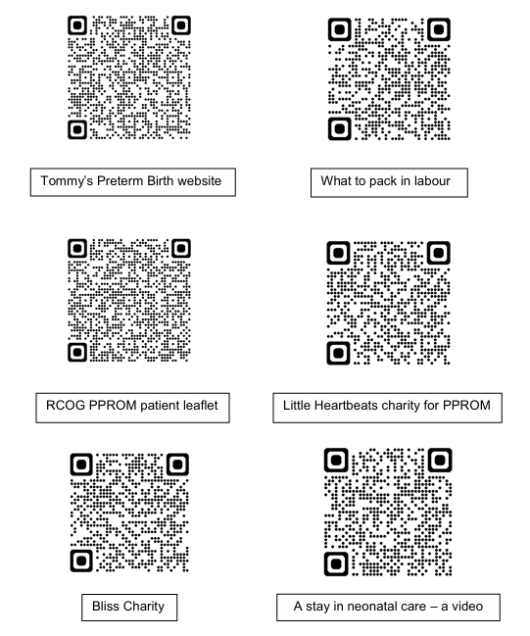

Further reading
There are other maternity information leaflets you may wish to read.
These are available on our East & North Herts NHS Trust website:
www.enherts-tr.nhs.uk/patient-information/

Leaflet information

You can request this information in a different format or another language;
please speak to your doctor or nurse.

Date of publication: August 2023
Version number: 2
Author: D. Thorpe
Reference: Maternity
Review Date: June 2029
© East and North Hertfordshire Teaching NHS Trust
www.enherts-tr.nhs.uk

