Service: Preventing Infections

Project: | East and North Hertfordshire NHS Trust website
Last updated: | 08/08/2019
Version: | 1.0
Owner: | Ian McCabe
Status: | Draft / Approved

URL: | http://www.enherts-tr.nhs.uk/services/preventiong infections

Page title: | Preventing Infections
Guidelines: The page introduction should answer the questions “What is it?”

Introduction and short description (i.e. excerpt)
Introduction:  (2 sentences) | Our dedicated staff are working hard to make sure you are given the best quality of care in a safe and clean environment. To help us do this we have made infection prevention one of our top clinical priorities.
Guidelines: The page introduction should answer the questions “What is it?” “Who is it for?” and “What does it do?” The description must include at least one real, actual noun besides the name of the product/service.

Page content

Guidelines: Indicate sub headers in bold and links by underlining.

The content itself must be unique (which makes it worthwhile for search engines to rank well) and covers a specific bit of information in a lot of depth. If a user had question about “Audiology at Lister Hospital”, this page would answer their query.

Default configuration allows for 1 single content page.
Your page should contain at least 300 words in order to rank well in the search engines.

Content: | Our infection prevention and control advice is available 24 hours a day to support our staff and answer any questions they have.  Our infection prevention and control advice is available 24 hours a day to support our staff and answer any questions they have.  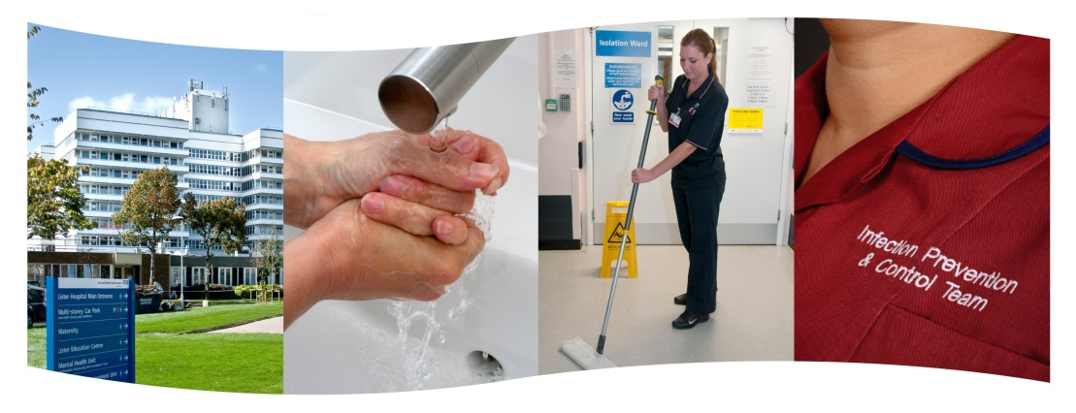  Below are example of some of the ways we are actively fighting infections in our hospitals  Hand Hygiene  To protect you from infections, our staff will clean their hands using a hand rub or soap and water every time they attend to you. If a member of staff appears not to have cleaned their hands, please feel free to remind them to do so – or speak to the nurse in charge if you prefer. We monitor regularly how well our staff, caring for patients, clean their hands, providing feedback to them when it’s necessary. You can also help reduce the risk of infections by cleaning your hands too whilst in our care, especially after you use the toilet and always before eating and drinking. If you could ask your visitors to clean their hands too, then that would be a great help.  Staff Training  All of our staff undertake infection prevention and control training, with regular updates.  MRSA screening of patients for both planned and emergency admission to hospital  We screen patients who are coming in to have a planned operation, especially those who have higher risk factors. This involves taking a swab to test for MRSA being present on your skin or nose. Find out more in our MRSA policy.  Our infection prevention and control strategy  The aim of our infection prevention and control strategy is to have no avoidable healthcare acquired infections and to become one of the top ten performing NHS Trusts in the country. To see the Trust’s latest infection prevention and control annual report, go to the Our Publications page where several formal Trust documents and reports can be found.  Infection Control Performance  MRSA bacteraemia Clostridioides difficile (C.diff)  2017/18 1 28  2018/19 2 27  Figures for monthly performance in the current year can be found in the Trust’s Board papers.  Read more about how to help prevent the spread of infection using our patient information leaflets

Contact details:
Guidelines: Provide contact details for the service.

Related resource(s):
Guidelines: Which documents, leaflets etc (contained within the resource library) are relevant?

Location(s): | Lister Hospital  Hertford County Hospital  Mount Vernon Cancer Centre  New QEII hospital  Renal units
Guidelines: Which hospitals is this service offered at? Select from predefined options shown above.

Aliases:
Guidelines: What other aliases does this service have or may commonly be searched for?

SEO title: | Infection Prevention | East and North Hertfordshire NHS Trust
Guidelines: The SEO title element of a web page is meant to be an accurate and concise description of a page's content. Optimal Format should be primary keyword or phrase followed by the brand Name.

META description: | Preventing Infections
Guidelines: Meta descriptions are commonly used on search engine result pages (SERPs) to display preview snippets for a given page. The meta description should employ the keywords intelligently, but also create a compelling description that a searcher will want to click. Optimal Length for Search Engines is 155 Characters.

